Moderation layer plan md file creation
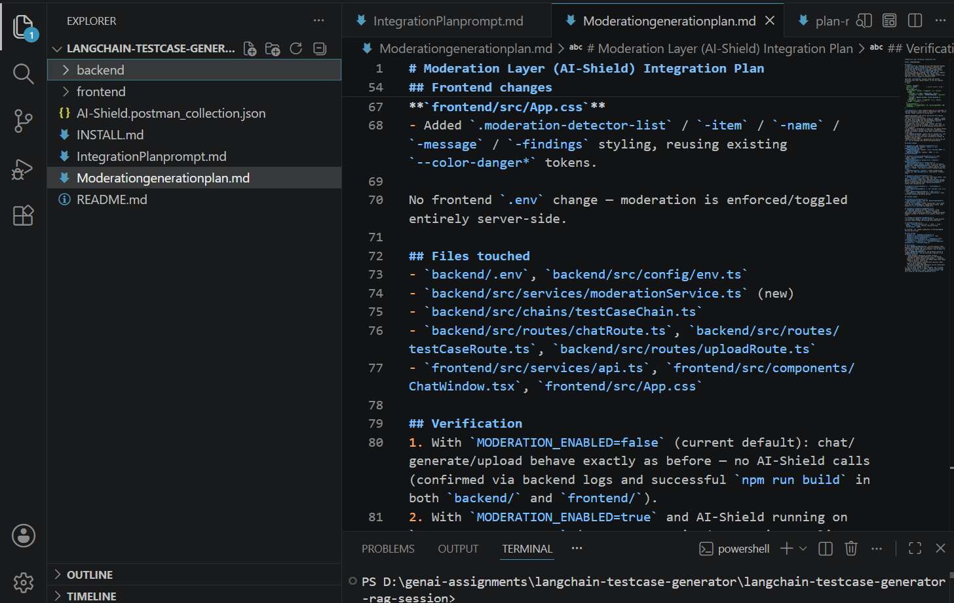
Implementation done with integrationplanpromt.md and moderationgenerationplan.md file
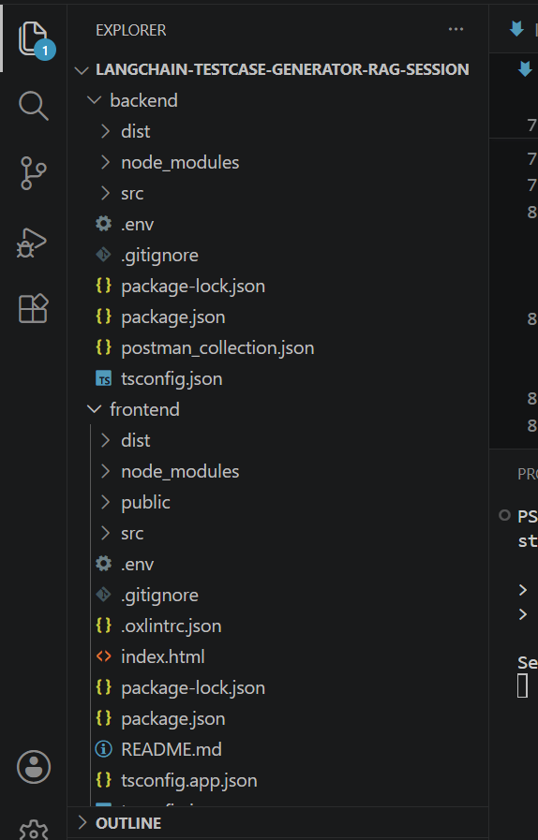
UI output
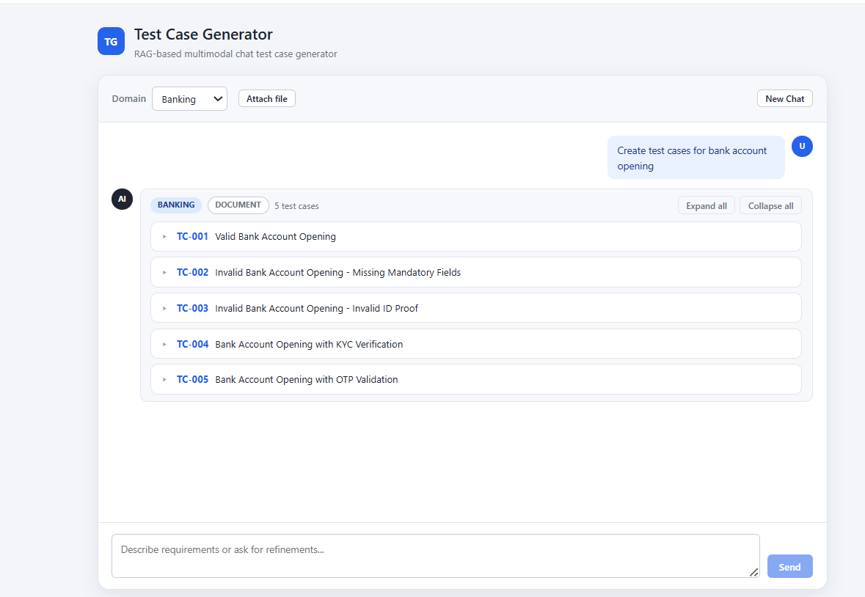
Given scenario to check for block by moderation layer
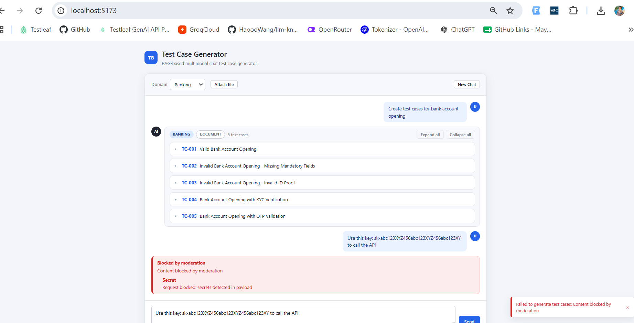
Given the same scenario by switch off the moderation layer
